Flowfield Dependant Variation using the Finite Element Method
An explanation and implementation in 2D

Philip Hahn

Table of Contents
Page

1 Overview 5
2 Theory 6
2.1 Implications of the FDV Theory 10
2.2 Finite Element Implementation 10
3 Implementation 14
3.1 Overview 14
3.2 Program Structure 14
3.3 Extracting Primitive Variables from Conservation Variables 14
3.4 Calculate the characteristic length of each element 15
3.5 Calculate time step using a CFL criteria 15
3.6 Element and Node Correlation 16
3.7 Convective Flux 16
3.8 FDV Parameters 16
3.9 Gaussian Quadrature 17
3.10 Domain Integral 17
3.11 Boundary Integral 19
3.12 Building the RHS of the equation 20
3.13 Dirichlet Boundary Conditions 21
3.14 Element-By-Element GMRES 22
3.15 GMRES Convergence 23
3.16 Convergence Criteria 23
3.17 Other Considerations 24
4 Code Description 28
5 Results and Validation to Existing Data 29
5.1 Isothermal Flat Plate 29
5.2 Adiabatic Flat Plate 34
5.3 Compression Corner Flow 38
5.4 Lid Driven Cavity Flow 43
5.5 Rearward Facing Step 46
5.6 Hypersonic Inlet 49
6 Conclusion 51
7 Further Investigation 51
Appendix A – Source Code 53

Table of Figures
page
Figure 1 - Isoparametric Element 10
Figure 2 - Prescribing Dirichlet Boundary Conditions 21
Figure 3 – Isothermal Flat Plate Density Contours 29
Figure 4 – Isothermal Flat Plate Pressure Contours 29
Figure 5 – Isothermal Flat Plate Temperature Contours 30
Figure 6 – Isothermal Flat Plate s1 Contours 30
Figure 7 – Isothermal Flat Plate s3 Contours 31
Figure 8 – Isothermal Flat Plate Residuals 31
Figure 9 - Adiabatic Flat Plate Density Contours 33
Figure 10 - Adiabatic Flat Plate Pressure Contours 33
Figure 11 - Adiabatic Flat Plate Temperature Contours 34
Figure 12 - Adiabatic Flat Plate s1 Contour 34
Figure 13 - Adiabatic Flat Plate s3 Countour 35
Figure 14 - Isothermal and Adiabatic Residuals 36
Figure 15 - Compression Corner Density Contours 37
Figure 16 - Compression Corner Pressure Contours 38
Figure 17 - Compression Corner Temperature 38
Figure 18 - Compression Corner s₁ contour 39
Figure 19 - Compression Corner s₃ contour 39
Figure 20 - Compression Corner Grid Refinement 40
Figure 21 - Compression Corner Residuals 40
Figure 22 - Lid Flow Convergence 42
Figure 23 - Lid Flow Vector Plot 43
Figure 24 - Lid Flow Stream Traces 44
Figure 25 – Rearward Facing Step Stream Traces - HAVE NOT CONVERGED 45
Figure 26 - Rearward Facing Step Vector - HAS NOT CONVERGED 46
Figure 27 - Rearward Facing Step Residuals - HAS NOT CONVERGED 46
Figure 28 - Hypersonic Inlet s1 parameter - HAS NOT CONVERGED 48
Figure 29 – Hypersonic Inlet Density - HAS NOT CONVERGED 48
Figure 30 - Hypersonic Inlet Streamtraces and s₁ Contours - HAS NOT CONVERGED 49

Table of Tables
page
Table 1 - Element and Node Correlation 15
Table 2 - File I/O for my FDV code 27
Table 3 - Isothermal Flat Plate Domain and Boundary Conditions 28
Table 4 - Adiabatic Flat Plate Domain and Boundary Conditions 32
Table 5 - Compression Corner Domain and Boundary Conditions 37
Table 6 - Lid Flow Domain and Boundary Conditions 41
Table 7 - Back Step Domain and Boundary Conditions 45
Table 8 - Hypersonic Inlet Domain and Boundary Conditions 47

Definitions

FDV = Flowfield Dependant Variation
CFL = Courant–Friedrichs–Lewy
R = Residual
M = Mach number
Re = Reynolds number
Pr = Prandtl number
EBE = Element by element
GMRES = Generalized Minimal Residual
RHS = Right Hand Side
LHS = Left Hand Side

Variables

U = Conservation variable (vector)
F = Convective flux (vector)
G = Diffusion flux (vector)
B = Source term (vector)
a = Convection Jacobian (matrix)
b = Diffusion Jacobian (matrix)
c = Diffusion Gradient Jacobian
s_{a}, s_{b} = Flowfield Dependant Parameters
s₁₋₄ = Flowfield Dependant Parameters
Δt = Time Step
Φ = Isoparametric Test Function
ξ, η = Isoparametric Coordinates
γ = Ratio of specific heats
c_{v} = Specific heat at constant volume
J = Transformation Jacobian; isoparametric to Cartesian coordinates
τ = Shear stress
μ = Viscosity
ρ = Density
v_{j} = Velocity
q = Heat Flux
p = Pressure
δ_{ij} = Kroneker delta (1 if i=j, 0 if i≠j)
n_{i} = Normal vector

Overview

I will start by presenting a brief derivation of the FDV equations from the Navier-Stokes equations in Section 2. The intention is not to present in detail every step of algebra, but rather to give the uninitiated a good overview of the process.

Section 3 is a discussion of FDV implementation details using the finite element method. Section 4 will detail some specific features of my implementation, which is included in Appendix A.

Section 5 includes some results I have generated with this code, including supersonic isothermal and adiabatic flat plates, a supersonic compression corner, a subsonic lid-driven cavity flow and back step, and a Mach 20 hypersonic inlet which details shock-boundary layer interactions.

Section Error: Reference source not found lists several issues I encountered along the way and suggestions for future classes, and Section 6 and Section 7 detail conclusions and future work, respectively.

Theory

We start with the Navier-Stokes system of equations written in conservation form,

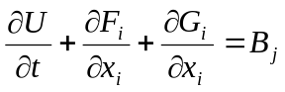 | 1

Where

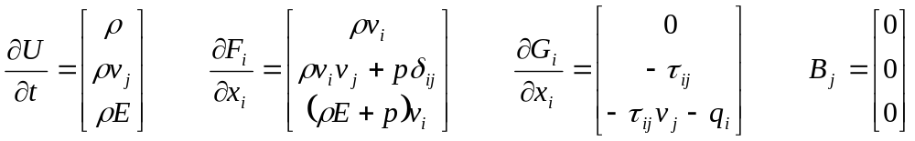 | 2

We set the source term, B, equal to zero for this derivation. This vector would be populated if we were considering, for instance, a reacting flow or a kinetic gas model, but from here on the term will be ignored. We can express the Navier-Stokes equations in terms of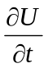,

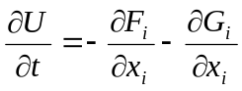 | 3

We then perform a form of Taylor series expansion about U^{n}, introducing parameters s_{a} and s_{b} to correspond to the first and second order derivatives with respect to time. We will investigate the meaning and significance of these parameters later.

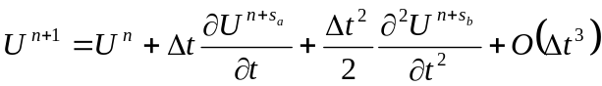 | 4

Where

 | 5
  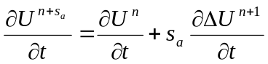 | 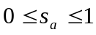
  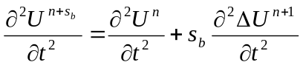 | 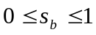
  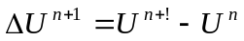

Substituting

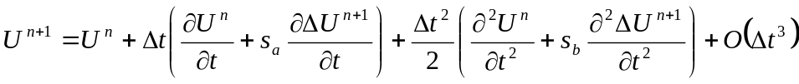 | 6

Now we introduce the Jacobians of convection, diffusion and the diffusion gradient. These Jacobians represent the flow interactions between the convective and viscous fluxes (F, G) and the conservation variable (U).

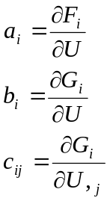 | 7

The formulations of these Jacobians can be found in the text.

Writing the first and second derivatives of the conservation variable in terms of the fluxes, and introducing the Jacobians into the second derivative,

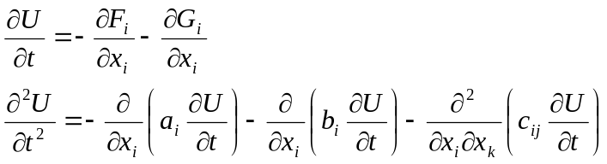 | 8

Substituting into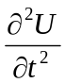,

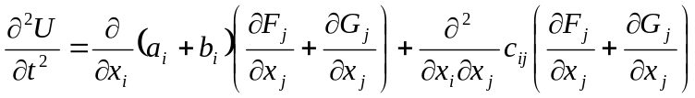 | 9

Now we can substitute and into the expansion of U^{n+1}.

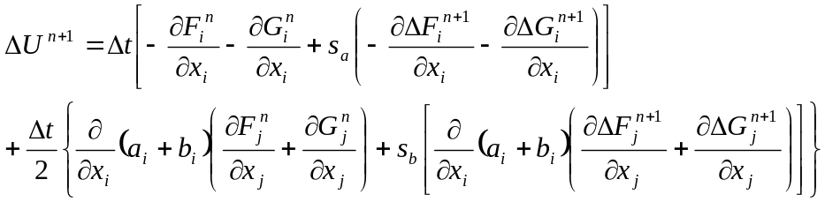 | 10

Now is the appropriate time to discuss s_{a} and s_{b}. These FDV parameters are a function of physical phenomena in the flow and serve the function of altering the equations to accommodate the flowfield phenomena. These flowfield dependant parameters are from where the theory derives its name.

It can be shown that for convective phenomena s_{a} has a functional dependence on Mach number (from shock tube physics). Likewise, for diffusive phenomena, s_{a} has a dependence on Reynolds number. Since F represents convective phenomena and G represents diffusive phenomena, we spit s_{a} into two unique variables, one for convection and one for diffusion. Likewise, we split s_{b} among F and G.

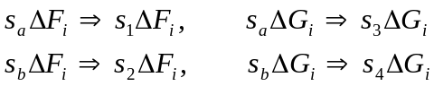

Where
s₁ = First order convection FDV parameter
s₂ = Second order convection FDV parameter
s₃ = First order diffusion FDV parameter
s₄ = Second order diffusion FDV parameter

In a finite element formulation these can be formulated quite simply. For each node in the finite element, the minimum and maximum value of the Mach and Reynolds number must be found. From these values, we can determine the flowfield dependant parameters to vary between 0 and 1, depending on the fluctuation of Mach and Reynolds number in the element.

For s₁ and s₂,

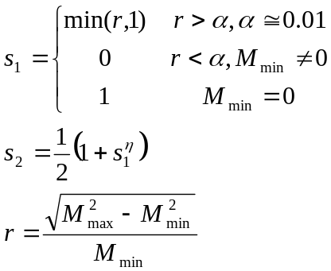 | 11

Likewise for s₃ and s₄,

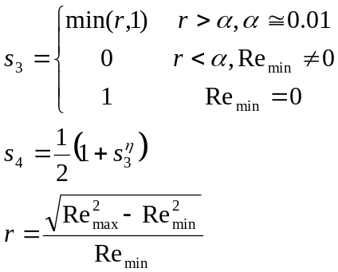 | 12

Alternatively for temperature-gradient driven flows the Peclet number can be used in place of the Reynolds number.

After substituting the flowfield parameters into the equation 10, we can express it as

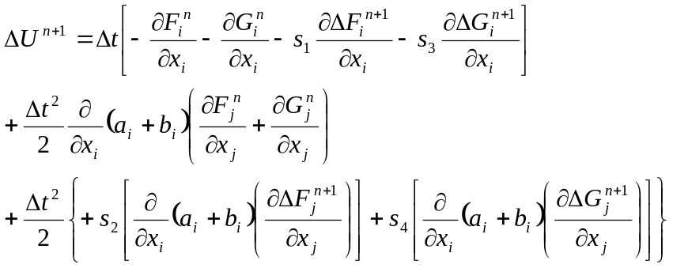 | 13

Finally, expressing in terms of the Jacobians a_{i}, b_{i}, and c_{ij},

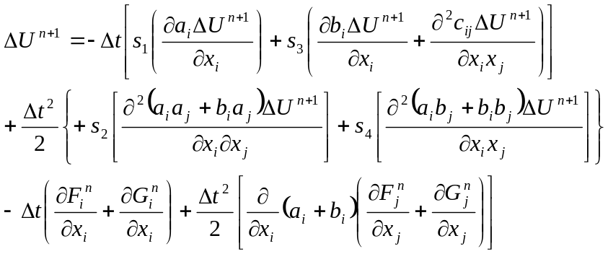 | 14

Implications of the FDV Theory

The FDV Parameters

The first order FDV parameters (s₁ and s₃) visually resemble the flow when plotted, as will be shown in Section 5, and are implemented for accuracy. The second order FDV parameters (s₂ and s₄) are a function of the first order parameters and are implemented for stability of the solution. The FDV equation solved in each element is modified by the values of the FDV parameters in that element, as shown in table 1

Equation Type | s₁ | s₃
Parabolic | 0 | Large
Elliptic | 0 | Large
Hyperbolic | Large | 0
Mixed | ≠ 0 | ≠ 0

Convection – Diffusion Interaction

Looking at the FDV equations we notice two terms where the convective and diffusive Jacobians interact.
s₂(b_{i}a_{j} +…
s₄(a_{i}b_{j} +…

This allows for accurate modeling of viscous-inviscid interactions.

Finite Element Implementation

In this report we will only concern ourselves with the finite element representation of the FDV scheme. It is possible to implement the FDV equations in a finite difference and finite volume methods as well.

In common with other CFD methods, we have a domain which is populated with nodes. Each node has a unique position and contains its value of the conservation variable. In a finite element formulation, an element is bounded by a group of nodes and equations which apply at these nodes are evaluated within this domain. This process is repeated until the entire area or volume is computed. Then the contributions from each element are summed together to form the solution.

In 2D then we can use any number of element shapes, for this project I used a 2D quadrilateral isoparametric element, as shown in Figure 1. A quadrilateral isoparametric element consists of four nodes in any arbitrary shape. This area can then be integrated by means of Gaussian quadrature, by using a test function to interpolate values from the four contributing nodes within the element and a Jacobian to translate from the Cartesian coordinate system (x, y) to the isoparametric coordinate system (ξ, η) as shown. In the isoparametric coordinate system the element is recast into a square with dimensions of (-1, -1) to (1, 1).

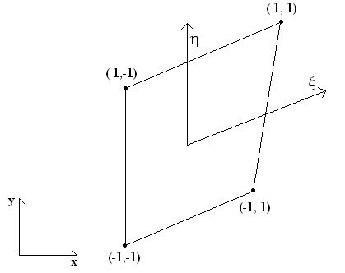
Figure 1 - Isoparametric Element

The test functions is a linear interpolation test function,

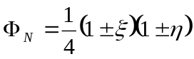 | 15

The sign used within the test function depends upon the node being interpolated. For instance, the lower left node in Figure 1 would use two negative signs since it is in the -ξ and -η quadrant.

Now, in order to form the finite element form of the global equations we must take the inner product of the test function with the residual of equations above.

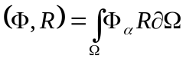 | 16

Where the residual is defined as the left-hand side of the final equation from Section 2 minus the right-hand side. Essentially, the goal is to drive the residual to zero.

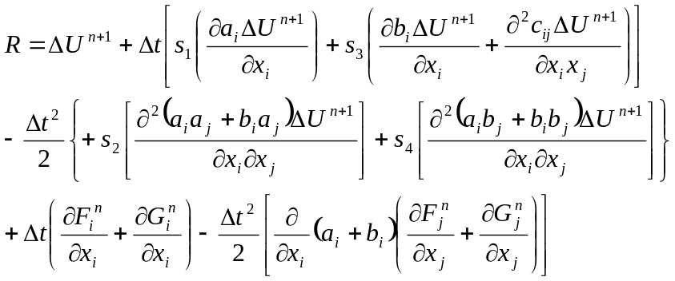 | 17

The inner product represents the transformation of the equations into a form we can analyze in a finite difference formulation. The test function is multiplied by each component of the residual to form the domain integral.

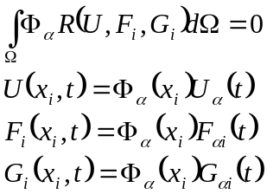 | 18

Then this domain integral is integrated by parts to expose the boundary conditions, using Green’s Theorem. This process is somewhat involved and omitted from this brief description. The point to bear in mind is that these equations are being translated to apply to an element with a discrete number of nodes, so we can evaluate the set of equations across the domain by evaluating it in many smaller elements.

These equations can be expressed compactly in tensor notation.

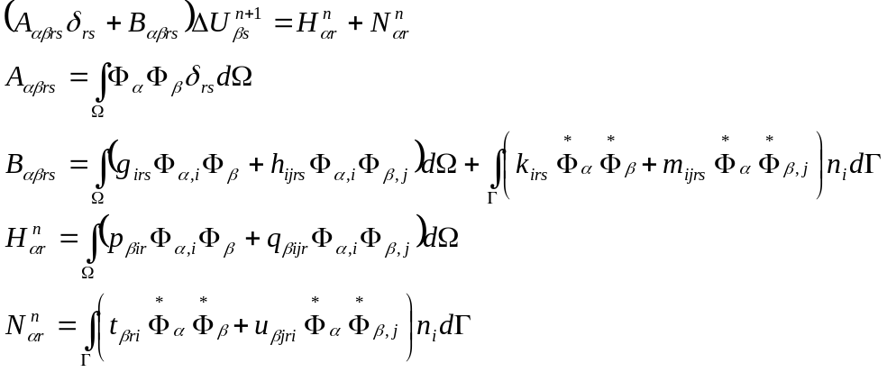 | 19

The indices α, β, iterate over the nodes in the element. The indices r, s iterate over the equations at each node, therefore there are 4 for 2D and 5 for 3D, more if advanced physics are programmed in (reacting flows, multiphase flows, etc.). The tensors in A, B, H and N are defined as follows

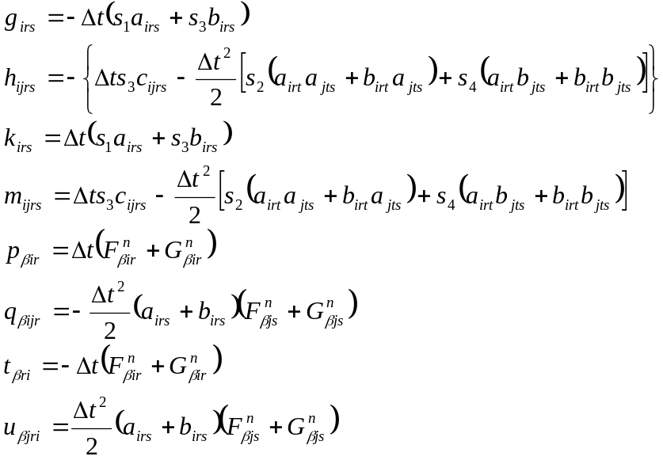 | 20

The domain integral is applicable in all elements. The boundary integral is only applied when the element is along the boundary of the domain, this is where Neumann, or natural boundary conditions are applied.

The above equations are expressed in a global formation, using α, β. In a finite element formulation the integral would be evaluated locally within an element and then summed together globally.

Implementation

Overview

In this section, I will attempt to translate theory into code by breaking the theory into pieces and discussing the implementation issues accordingly. Every attempt is made to make this discussion generic, programming language and platform agnostic.

Program Structure

There are multiple ways to approach the problem. This is a very simple, straightforward structural view of the program.

- Allocate and initialize nodes, elements and boundary conditions
- Calculate program constants
  - Thermodynamic – γ, c_{v}, Sutherlands’ law, etc.
  - Dimensions - #nodes, #elements, #dimensions
- Calculate characteristic length of each element
- Enter an iterative loop until the solution is complete
  - Clear temporary storage variables, if any
  - Extract primitive variables from conservation variables
  - Calculate convective flux (F) for each node
  - Calculate CFL number, update Δt
  - Calculate the FDV parameters in each element
  - Gaussian quadrature of the domain and boundary integrals
  - Apply Dirichlet Boundary Conditions
  - Solve system of equations utilizing EBE-GMRES
  - Enforce Dirichlet boundary conditions on updated variables
  - Calculate some convergence criteria
- Exit program

Extracting Primitive Variables from Conservation Variables
The conservation vector, 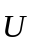, along with thermodynamic properties γ and c_{v}, sufficient information to determine the physics of the flow.

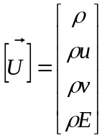 | 21

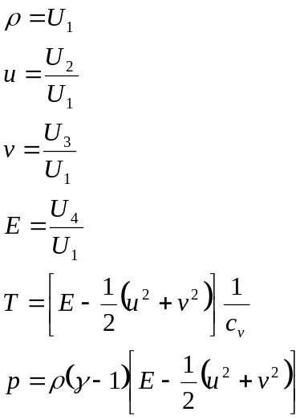 | 22

Calculate the characteristic length of each element

The characteristic length of a 2D element is the square root of the area of the element. For an arbitrarily shaped finite element you simply integrate over the area to calculate the area of the finite element to determine the area. This area can be calculated using the determinant of the Jacobian. Using Gaussian quadrature,

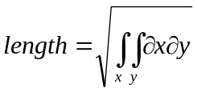  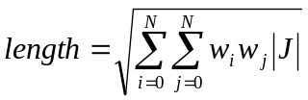 | 23

Calculate time step using a CFL criteria

The CFL number is a coefficient, relating time, the characteristic length of a finite element and the rate at which information propagates. To utilize the CFL criteria, calculate Δt in each finite element using the prescribed CFL number, then choose the lowest Δt calculated as your Δt for the iteration.

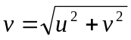  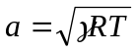  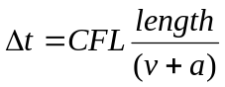 | 24

Element and Node Correlation

The finite element consists of a group of nodes. With this group of nodes the boundary integral is calculated. If your element lies against a boundary, then the boundary integral is calculated as well.

This is all fine and good but one thing that must be recognized early on is that nodes will be shared between finite elements. So we will need a way to relate the numbering of a node on the grid and the numbering of the node within a given finite element.

One way to do this is to have an array of pointers within an element class or data structure that point to the appropriate nodes in a node data structure for that particular element. For example, within one element we may have the following correlation

Table 1 - Element and Node Correlation
Local Node | Global Node
0 | 0
1 | 31
2 | 32
3 | 1

So for instance when we calculate the domain integral within a given element, we use the local node numbering (the order of the nodes within our element pointers or list). But when we go to solve the entire domain using a solution method like EBE-GMRES, we will not be updating each element but rather the individual nodes themselves. Then during these calculations we need to know the correlation between each element and the nodes they are comprised of.

Convective Flux

The convective flux is calculated at each node and requires values derived only from the conservation variable, and can be calculated prior to the domain or boundary integrals. The viscous flux, G, on the other hand involves properties unique to each element. This is described in Section 3.10.1.5.

FDV Parameters

Each element has its own set of FDV parameters, based on of the nodes within the element. There are four FDV parameters for this project, as described in Section 1.

To calculate the FDV parameters, first we must calculate M_{max}, M_{min}, Re_{max}, and Re_{min} within each element by first calculating M, Re at each node and determining the largest and smallest values. Be careful to program around negative and zero temperature’s (which will cause unreal values in your Mach number calculation). Also bear in mind the limits and conditions posed on the implicit parameters, as described in Section 2.

Gaussian Quadrature

While an in-depth exposé is beyond the scope of this document, the concept behind Gaussian quadrature is transforming a given length, area or volume into a specified (unit or otherwise) length, area or volume and then integrating by sampling at periodic points with a given weight function assigned to those points. Put simply in a summation form, in 1D,

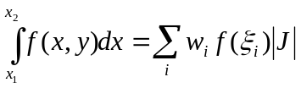 | 25

Where w_{j} is the weighting function and x_{j} is the sampling point. 2D and 3D areas and volumes can be evaluated in the same fashion, simply by summing in the additional directions.

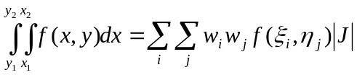 | 26

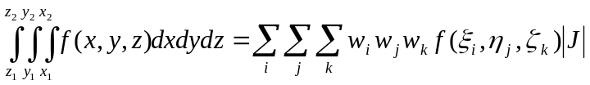 | 27

Domain Integral
The domain integral consists of everything that is inside of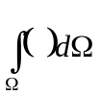. Everything that appears within the domain integral is performed in quadrature. This is important. Every calculation listed in the procedure below must be performed at every Gaussian point, with it’s unique weight functions and abscissae, in each finite element.

Procedure

- Calculate the test functions
- Calculate the Gaussian point values of each variable
- Calculate derived values
- Calculate Jacobians
- Calculate G, dG
- Sum intermediate matrices
- Sum A, B, H

Calculate the test functions

Calculate values of 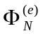, 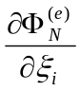 and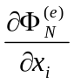 as demonstrated in the text. In addition, we need to calculate the determinant of the Jacobian,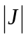, in each element.

Calculate the Gaussian point values

Now using the test function and the derivative of the test function with respect to Cartesian coordinates, calculate the variables you need in order to calculate the Jacobians and fluxes F, G. To calculate a value at a Gaussian point, use the test function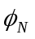

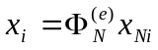 | 28

Where x_{Ni} is the value of x at node N, i=1,2 (the coordinate directions). To take a derivative, it is the same procedure but there is an additional variable, the derivative direction

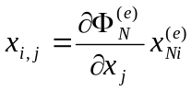 | 29

So now in addition to summing over directions and nodes, you are also summing over derivative directions (∂x, ∂y). So for example, if you want to calculate element velocity and derivatives of element velocity, you would use the above verbatim. If you wanted to calculate a single variable, say the temperature T and derivative ∂T, the “i” index drops out as it is a scalar, not a vector.

Calculate derived values

Now that all of the flow properties are known at the Gaussian point of interest, derived values like viscosity, heat transfer coefficient and shear stress can be calculated.

Calculate Jacobians

Now we can calculate the Jacobians, using the element values we formed through quadrature. Implement as found in the book. One note on notation: in the b Jacobian there are several terms that exist which are derivatives of the conservation variable, U.

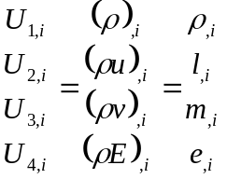 | 30

These derivatives can be formed simply by using the derivative of the test function with respect to Cartesian coordinates, as shown below

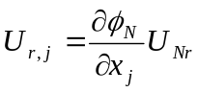 | 31

Calculate G, ∂G

As you recall the convective flux F is calculated outside of quadrature at each node. The value for the node is then calculated using the test functions.

G on the other hand requires several parameters that cannot be directly derived from the conservation variable, but rather must be interpreted within the finite element. These parameters are ∂T and τ (which is a function of ∂V). These derivatives are formed within the element using the spatial derivatives of the trial functions. Therefore, we need to wait until we are in quadrature to form G at each node.

So now go back and calculate G at each node. Use the test function to determine G for the element. Use the derivative to the test function to determine ∂G for the element.

Sum the Domain Integral

Sum the complete domain integral, both the left and right-hand sides, using the intermediate matrices, and multiply by the Gaussian quadrature weights and the determinant of the Jacobian in order to integrate over the finite element.

Boundary Integral

Make more point for point parallel to domain. Point out parallelism.
The calculation of the boundary integral parallels the domain integral precisely except for two caveats
- The test functions are now 1D test functions rather than 2D test functions. We are interpolating along a line integral consisting of two nodes, rather than a domain of four.
- Along with calculating the test functions, we need to calculate surface normals.
- Prior to calculating Jacobians, we must apply Neumann boundary conditions.

Surface Normals
Normals are calculated geometrically and are tied to choice of coordinate system, element numbering, etc. Normals point out of the domain. The normals have a magnitude equal to the length of the element surface they represent.

Boundary Conditions
The boundary conditions require care and are a large part of making your CFD code a success. Boundary conditions – both the Neumann boundary conditions described here and the Dirichlet boundary conditions described in Section 3.13 – are what drive the domain to a solution. As you read through the domain integral you probably noticed the procedure didn’t care about what element we were in. Well, now we start to become concerned about which element we are acting on. We only calculate boundary integrals along the surfaces of elements which are at the boundary of the domain. It is 1D integration between the two nodes on the surface in question. Therefore, although the domain integral procedure is followed, we must only consider two nodes in our summations, and only use 1D test functions.

Boundary conditions are specific to the type of boundary (flat plate, inflow, outflow, etc.) and are listed in the book. Each of the example cases I list in Section 5 includes boundary condition information. You must enforce boundary conditions immediately after interpolation, prior to calculating Jacobians, μ, τ, etc.

Building the RHS of the equation

We need the RHS of the equation in global form for the GMRES solver. You could also do the left hand side in global form, but using the element and node correlations you can do an element-by-element correlation which is much faster.

The reason the RHS should be in global form will be made apparent in the Dirichlet boundary condition section. We need to be able to zero parts of the equation. Now it would be possible to do this in the local form, but you’d be doing it up to four times, once in each element that contains a reference to the node, and this would probably require an additional correlation table. This is easier, in my opinion.

If you have your global to local correlation handy this is a straightforward operation.

- Allocate an array (number of nodes * number of equations per node)
- For each element,
  - Iterate over your RHS equation
  - Use your global->local correlation. Mine is called global[], given the local node number from 0-3, it returns the global node number, like this

for (int i=0; i<4; i++)
{
int gi = e->global[i];

for(int k=0; k<4; k++)
{
H[ gi * 4 + k ] += e->rhs[4*i+k];
}
}

So for each equation in each node we iterate over the right hand side in the local element “e”. “i” counts the nodes and “k” counts the equations. “gi” is the global node number corresponding to the local node number “i”.

So we count 1,2,3,4 equations corresponding to node 1 in rhs, then 1,2,3,4 equations in node 2, which are offset by 4 because the first node occupies the first four slots in rhs, etc. We then sum them into the global RHS vector, denoted as H, using the global correlation of i, “gi”, but otherwise keeping the formula the same.

Dirichlet Boundary Conditions

Dirichlet, or prescribed, boundary conditions are prescribed outside of quadrature, after the matrices are formed (so after both domain and boundary integration), before the GMRES solver. They are prescribed by a manual manipulation of the matrices in each boundary element. Say I prescribe a value of x at a given node, and would like to retain that value throughout the execution of the program. If I zero out the row and column that contribute to that value and change the [A]_{i,i} location to one, and zero out the right-hand side, the equation for that prescribed value changes to

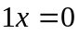 | 32

For which the answer is x=0. Which is perfect, we don’t want our Dirichlet boundaries to change. We want them fixed as they are. Zero would then be summed into the existing value of x, which would remain x. There is just one change to make from the 1D case: in 2D, we prescribe 0.5 instead of 1 (because along a boundary there are two matrices “touching” the node, 0.5+0.5=1.0).

So if you want to set u=0, v=0, (flat plate adiabatic boundary conditions), this is exactly what you do. You zero out the rows associated with the equation, and you zero out the columns associated with the two nodes in the boundary. For example, say you have a flat plate at nodes 1 and 2. You would zero out terms 1-8 (1-4 for node 1, 5-8 for node 2) in columns 1-8 (1-4 for the first node, 5-8 for the second node), and then all of the rows from 1-8, and then place 0.5 in the diagonals. You do not zero out anything in the rows associated with 3 and 4, because you need to let nodes 1 and 2 interact with the flow. If you zeroed out the entire column then in essence you would be saying the boundary has no impact on the flow.

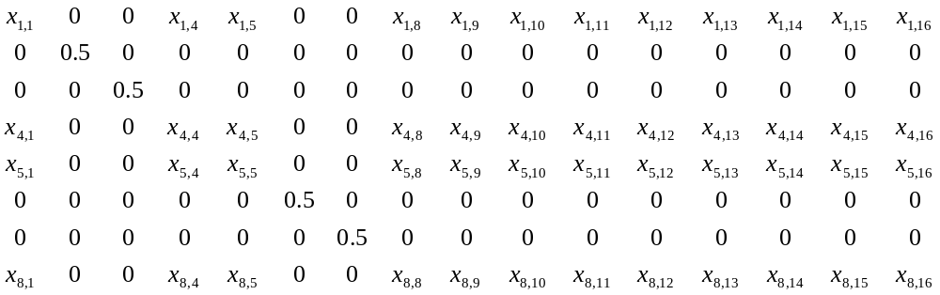
Figure 2 - Prescribing Dirichlet Boundary Conditions

Figure 2 only shows the first eight rows of an element which has a plate boundary condition. The remaining 8 rows remain intact.

There is one case that is slightly more convoluted, fortunately only one. It’s the energy term on the isothermal wall. On the flat plate, we prescribe u=0, v=0, and T=T_{wall}. This means E is fixed, because T = f(E, γ). However, the conservation term is ρE, and ρ must be allowed to fluctuate, otherwise the pressure would be fixed as well, since p=f(ρ, E, γ).

So we need to do a little bit more here than just wipe out rows and columns and prescribe a 0.5. Namely we need to set up an equation of balance in the ρ row and the ρE row.

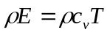 | 33

Element-By-Element GMRES

An in-depth look at the GMRES algorithm is beyond the scope of this document. It is simply a method that solves a system of linear equations,

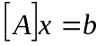 | 34

Where A is an nxm matrix and is a vector of dimension m for the vector. It is an iterative method which converges on the correct answer over a number of iterations.

What is novel about this method is the ability to do it element by element, hence the term EBE-GMRES. In a EBE-GMRES scheme the matrix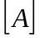 is never actually formulated, which is a great advantage. Imagine a system of equations with 10,000 nodes and 4 equations at each node. This would result in a matrix with dimensions of 40,000x40,000, although most would be zero since (in two dimensions) a single node can participate, at most, in four finite elements and thus be influenced by no more than eight other nodes. That means any given row or column contains no more than 32 entries out of the 40,000 allocated rows.

The way this is implemented is a series of loops iterate over each element and then use the element to node correlation discussed in Section 3.6 to perform the appropriate multiplication with. This saves many thousands or millions of multiplications by the number zero and saves much time as compared to say the Jacobi method.

One of the disadvantages is that it is not as straightforward to parallelize although it is not impossible.

GMRES Convergence

Once you have performed the Givens’ rotation on the Hessenberg matrix, you are left with a (m+1) x (m) matrix and an associated (m+1) vector. The last row of the matrix is comprised entirely of zeros. However, the same rotations are also applied to a column vector and its last entry will not be zero, rather it will be equal to the residual of the system of equations. This residual is your convergence criteria. You want to drive this number as low as possible.

One convergence criteria I have gleaned is 10E-9 x || b ||, the magnitude of the initial right-hand side vector of the entire system of equations, which if your initial guess is zero would be your initial error. This would represent a reduction in error of nine orders of magnitude.

Convergence Criteria

The convergence of the CFD solution itself is a function of the conservation variable, U, and its change from iteration to iteration. There are a few ways to quantify the “doneness” of the solution.

Probably the easiest way is to take the RMS of 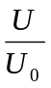, that is,

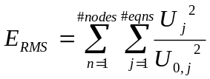 | 35

This quantifies the mean change in the conservation variable over the last iteration. Another way to look at it would be to take the RMS of the individual components of the conservation variable

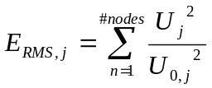 | 36

Which allows for observation of each conservation variable and provides additional insights, for example, you may observe the energy term is relatively constant from iteration to iteration; however one of the velocity terms may be several orders of magnitude higher than the other terms. This would probably indicate that you should let it run a little longer to let the lone higher error work its way out.

Another way to look at it would be to observe ΔU^{n+1}, the output from the EBE-GMRES routine. This is the difference between U and U₀. This should approach zero when converged.

Note that convergence has nothing to do with accuracy. You can have a perfectly converged solution that is meaningless.

Other Considerations

Nondimensionalization
Nondimensionalization is a useful extension to the code. For one, when you generate a grid, the grid isn’t tied to specific dimensions, so it is generic. You can scale the grid with a few parameters instead of regenerating the entire grid. Likewise, changing flow parameters is a very straightforward process of changing one or two variables.

Perhaps most importantly is it exposes key engineering parameters like the Mach, Prandtl and Reynolds numbers in the Navier-Stokes system of equations. So you can re-run a case by simply changing the nondimensional parameters and get a new set of solutions.

The only change made to the formulation of the FDV equations is that G is multiplied by the inverse of the Reynolds number,

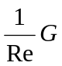 | 37

The rest of the modifications take place on input variables and intermediate calculations. First, the following parameters must be specified.

- Free stream Mach number
- Free stream Prandtl number
- Free stream Reynolds number
- Free stream Temperature (dimensional)

The first three numbers are nondimensional parameters. The free stream temperature is the dimensionalized temperature (Rankine, Kelvin, etc.), which will be used to nondimensionalize further parameters.

From these four parameters we can nondimensionalize the CFD code. When the input conditions are generated, at each node, each variable is expressed in terms of the free stream conditions, as shown below. The program never has to deal with the dimensionalized quantities

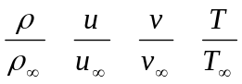 | 38

So at the free stream, all parameters would be set equal to 1.

There are several more parameters we need, but are all derived from the four input parameters listed above. First, we need the nondimensionalized parameter for Sutherland’s law in order to calculate the heat transfer coefficient. This is where our free stream temperature enters,

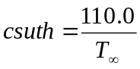 | 39

Next, we need a nondimensionalized specific heat at constant volume, c_{v}, and a nondimensionalized gas constant

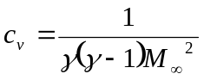 | 40

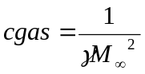 | 41

Finally, if you plan on running an isothermal wall case, you need to specify that temperature (divide by T∞). Then the isothermal wall temperature is enforced in the Dirichlet boundary conditions.

All of these parameters are calculated up-front, once, in your program, never to be thought about again. Within your program, the only changes that need to be made are as follows:
- Calculation of μ, k

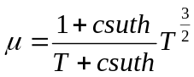 | 42

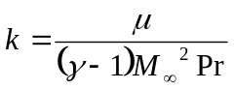 | 43

- G must be manipulated as shown previously

You may have noticed we never specified a length. The length appears in the Reynolds number.

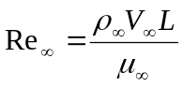 | 44

The parameters ρ∞, V∞ and Re∞ are given. We can calculate μ∞ using Sutherland’s law, and then rearrange the equation and solve for L. One unit in our nondimensionalized CFD grid is equal to L dimensionalized units.

File Output

Some provision should be made for regular file output in order to verify program operation and to experiment with intermediate results. There are a number of commercial packages that provide a public format for writing files, some of these packages even have finite element file formats which make writing an output file a breeze.

I used Tecplot because it was available at work. The FEBLOCK format type is straightforward for use with finite element CFD values.

Program Restart Capability

In conjunction with file output there should be a method to re-initialize the CFD program with a partially converged solution, for example restoring a run after a power failure.

Look at the inputs to the CFD program and think about what remains constant throughout the run (things like nondimensionalized parameters, GMRES and quadrature iteration controls, etc.), these things you do not have to preserve. If you are not performing any kind of adaptive meshing, etc. then you do not need to preserve element associations or boundary conditions. These can all be derived from the initial input files (although someday you might be interested in these things). What you do need to preserve are the values of the conservation variables at each node, or at least enough properties to reconstruct the conservation variable.

The way I do this is by dumping all the values I need into my Tecplot output files,
- Density
- Velocities
- Temperature

That is all you need, in conjunction with your original input files. From that you can reconstruct the density and velocity terms in the conservation variable. For the energy term you just need one additional piece of information, the gas constant, but this can be derived from the input files initially used to trigger the run.

Code Description

My code is a non-dimensionalized form of the FDV equations and its implementation mirrors the description above. It presently handles 2D problems only. The code is parallelized to run on multiple core processors. It has been tested on a dual core and quad core systems with great success.

My code utilizes three input files for each case

Table 2 - File I/O for my FDV code
File | Description
filename.aero | Provides aerodynamic coefficients for nondimensionalization.
filename.control | Provides constants for control and geometry
filename.grid | Provides node information, element correlations and boundary conditions

The program, upon execution, reads in the three associated files, generates the appropriate nondimensionalized constants and generates the node, element and boundary condition associations for the case. Then memory is allocated for the GMRES, FDV and Gaussian quadrature routines. Each element’s characteristic length is generated. Finally, the main iteration loop is entered, with the procedure as described in the implementation section.

Each iteration my program records to file a Tecplot output file for visualization. In addition this file can be used to re-start a set of runs if desired in the future.

The code is included in Appendix A.

Results and Validation to Existing Data

Each subsection in section 3 will document a separate CFD solution I generated with my code. These results have been verified to materials handed out in class but have not been verified or validated to experimental data or theory.

Isothermal Flat Plate

The isothermal flat plate is a flat plate with a constant wall temperature along the plate in a uniform flowfield. The domain contains 1395 nodes. The inflow parameters are M=3, Re=1000, Pr=0.72, T∞=218.6 K.

Table 3 - Isothermal Flat Plate Domain and Boundary Conditions
 | 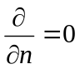
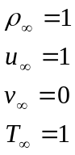 | 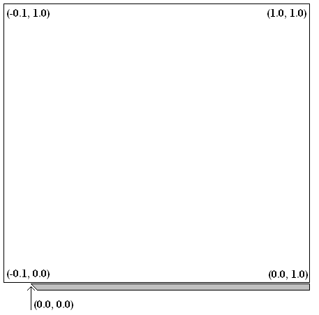
  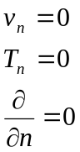 | 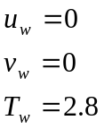

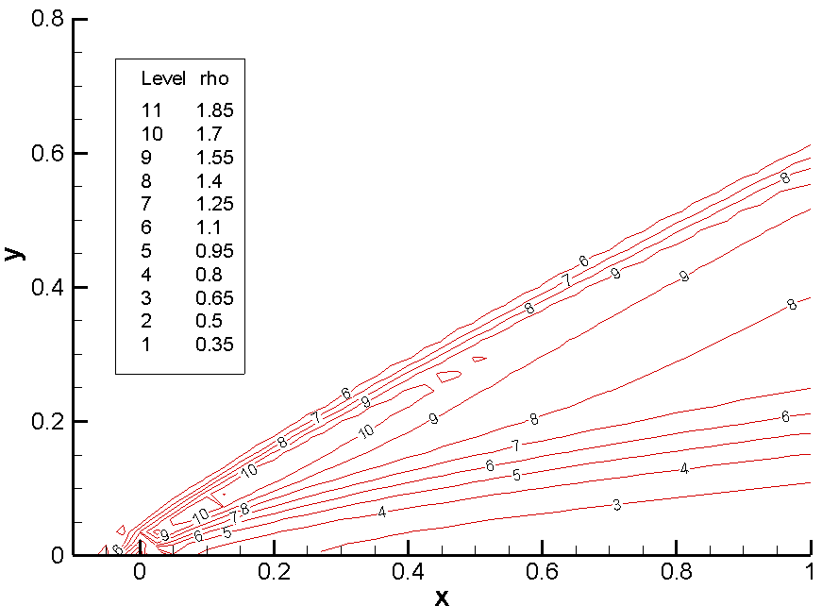
Figure 3 – Isothermal Flat Plate Density Contours

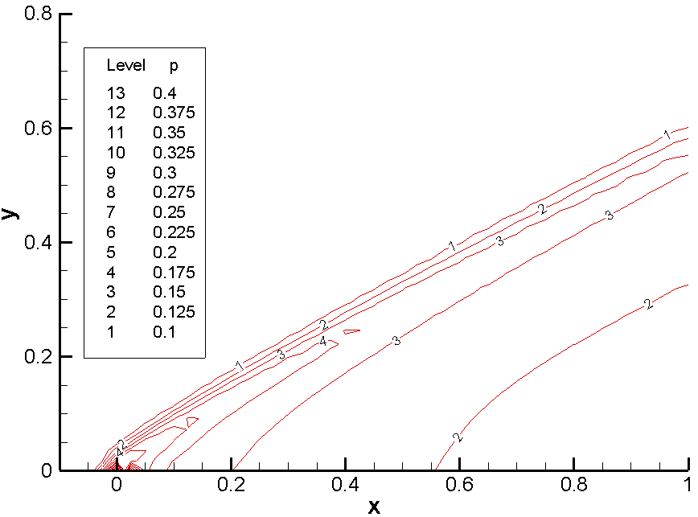
Figure 4 – Isothermal Flat Plate Pressure Contours

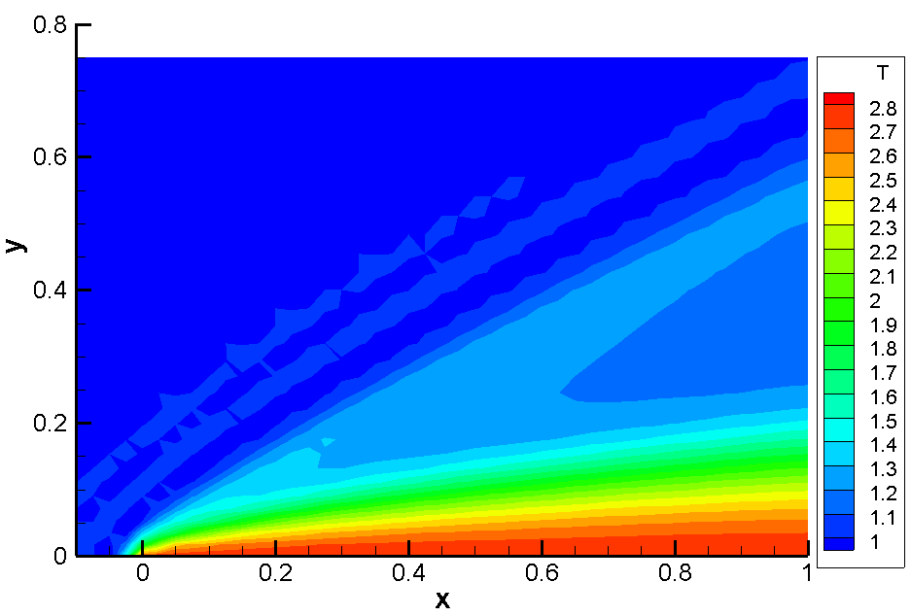
Figure 5 – Isothermal Flat Plate Temperature Contours

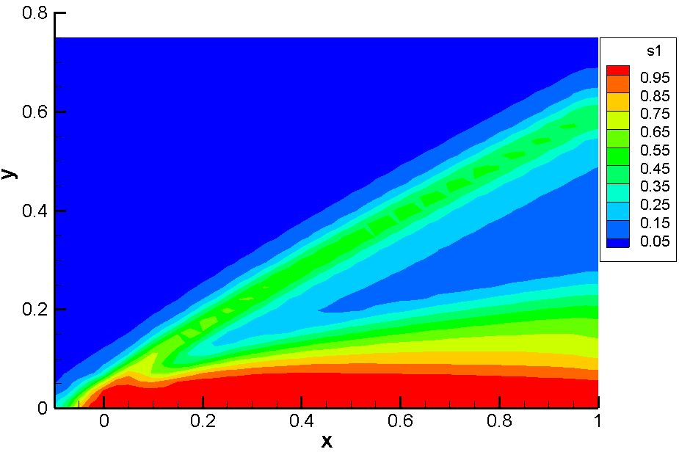
Figure 6 – Isothermal Flat Plate s1 Contours

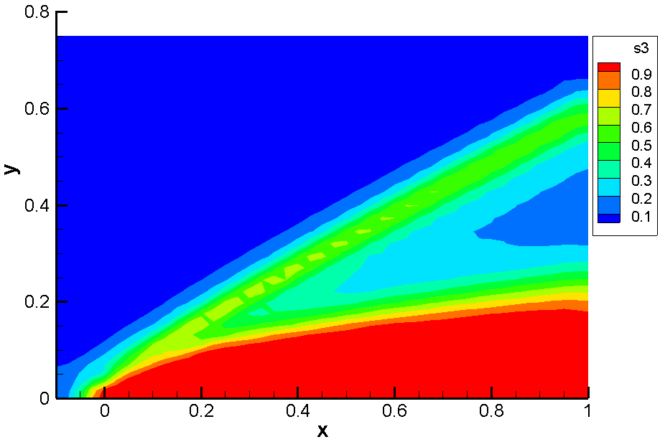
Figure 7 – Isothermal Flat Plate s3 Contours
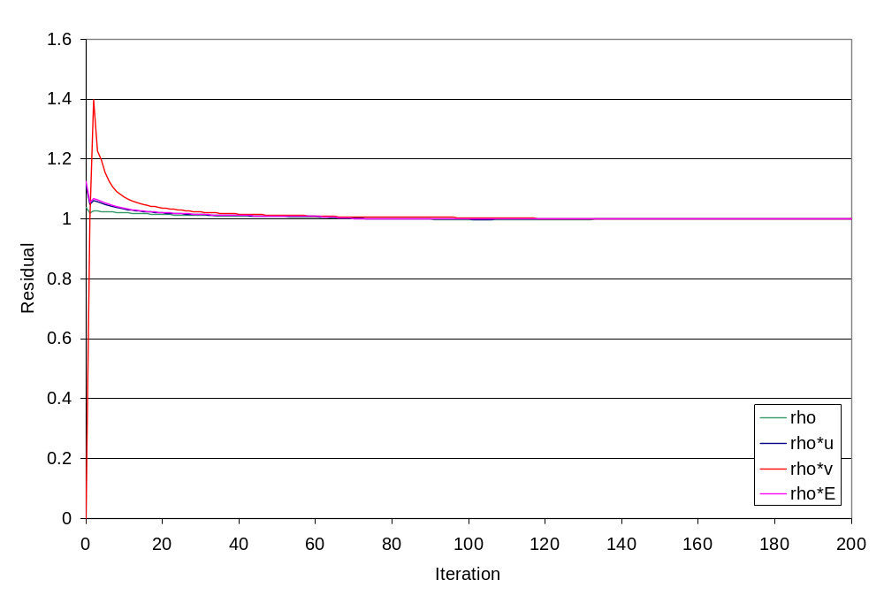
Figure 8 – Isothermal Flat Plate Residuals

Adiabatic Flat Plate

This case is the same as the Isothermal Flat Plate in section 5.1, except the plate temperature boundary condition is adiabatic instead of isothermal.

Table 4 - Adiabatic Flat Plate Domain and Boundary Conditions
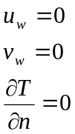

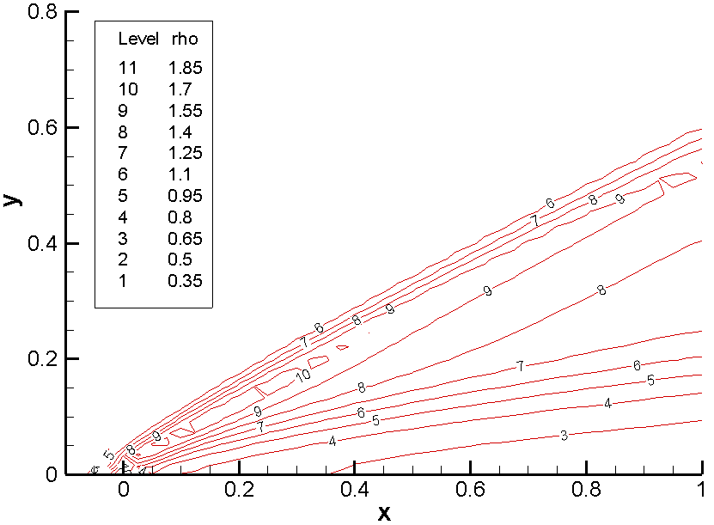
Figure 9 - Adiabatic Flat Plate Density Contours

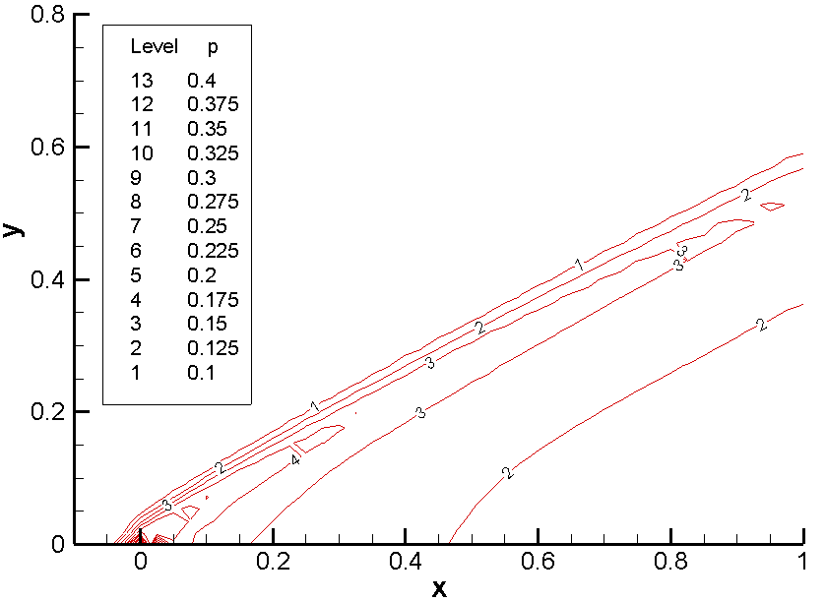
Figure 10 - Adiabatic Flat Plate Pressure Contours

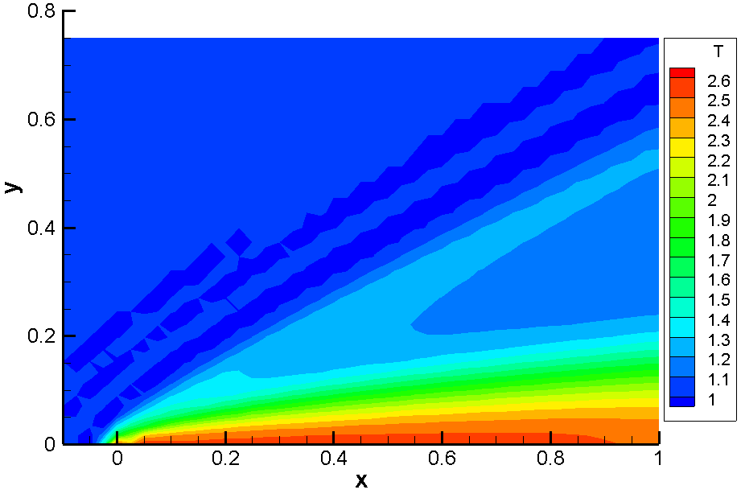
Figure 11 - Adiabatic Flat Plate Temperature Contours

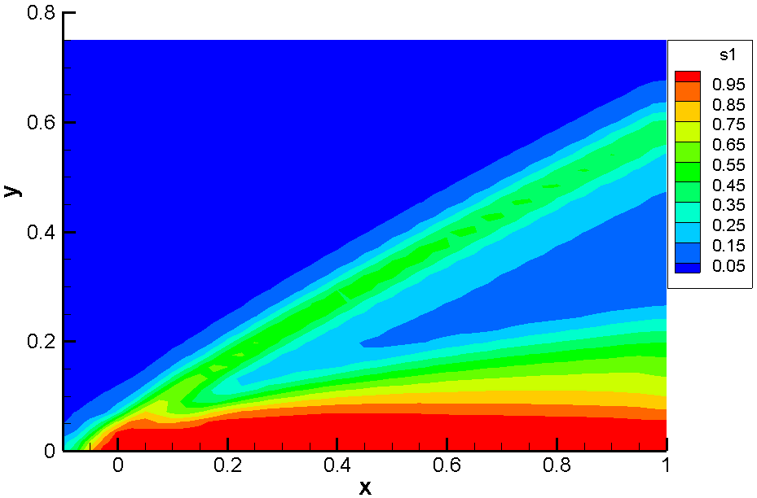
Figure 12 - Adiabatic Flat Plate s1 Contour

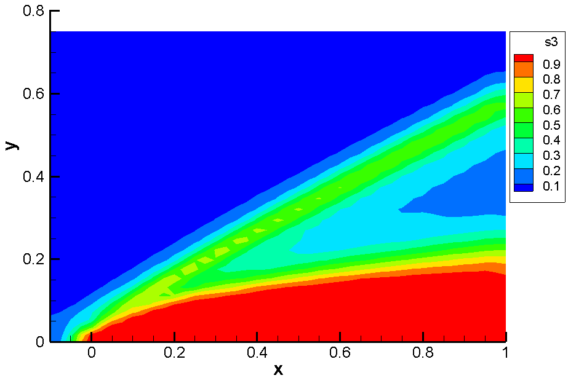
Figure 13 - Adiabatic Flat Plate s3 Contour

Isothermal and Adiabatic Flat Plate Comparison

The GMRES solver in the adiabatic case was able to converge to a specified tolerance every iteration. I believe this was due to the fact that I was not artificially prescribing a temperature to the flat plate, essentially adding a forcing function to the solution, but letting the solution converge naturally to the post-shock wall temperature. By making those matrix manipulations it made the system of equations more difficult for the GMRES solver to solve.

If we take a very close look at the residuals as shown in Figure 14, it is shown that the adiabatic flat plate case does converge more quickly than the isothermal case. This correlates with the conjecture made in the last paragraph.

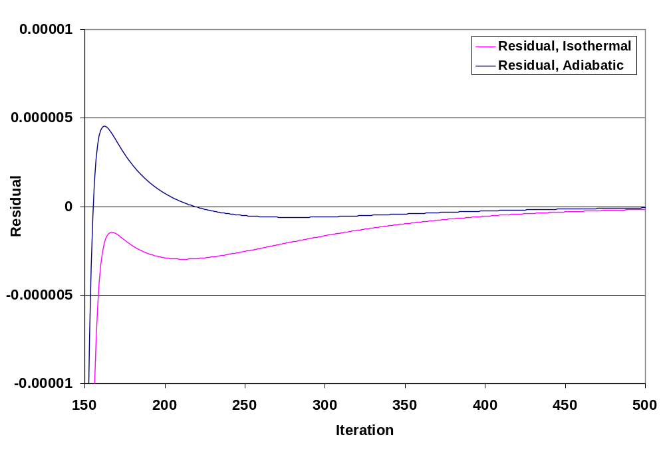
Figure 14 - Isothermal and Adiabatic Residuals

Flat Plate Length

I ran the two flat plate cases in sections 5.1 and 5.2 to correspond to data distributed in the class. However upon inspection of the Reynolds number it becomes apparent that the actual length of the nondimensionalized plate is approximately 0.013mm in length. It represents only the very tip of the shock structure and is insufficient in length to judge whether or not the shock angle with respect to the plate agrees with theory, for instance, a θ-β-M diagram. I attempted to increase the Reynolds number with the current mesh but could not get it much higher without running into convergence issues.

I have a more refined mesh to test at a higher Reynolds number but did not have the time to complete running them at multiple Mach numbers.

Compression Corner Flow

The ramp flow case is a flat plate, 1 unit length, with a 10° compression corner, 1 unit length along the x-axis. The goal here is to see two shocks, the leading edge shock off of the plate and then a secondary shock formed by the compression corner. M=3, Re=10,000, Pr=0.72.

Table 5 - Compression Corner Domain and Boundary Conditions
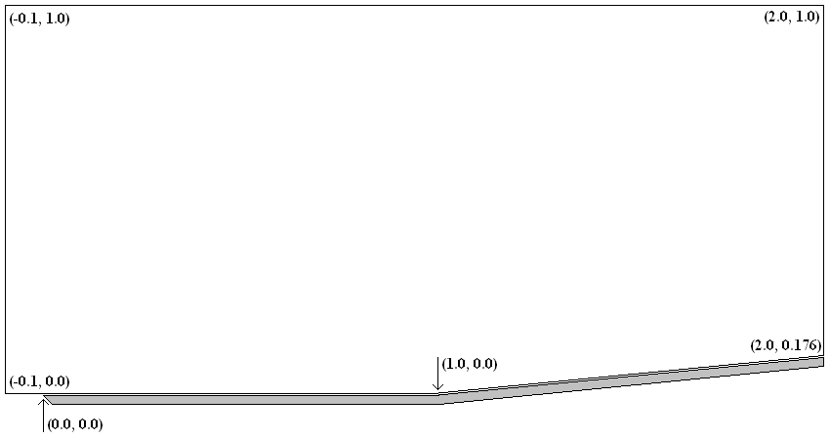

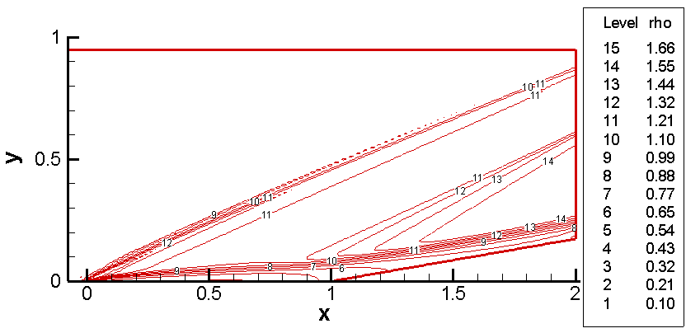
Figure 15 - Compression Corner Density Contours

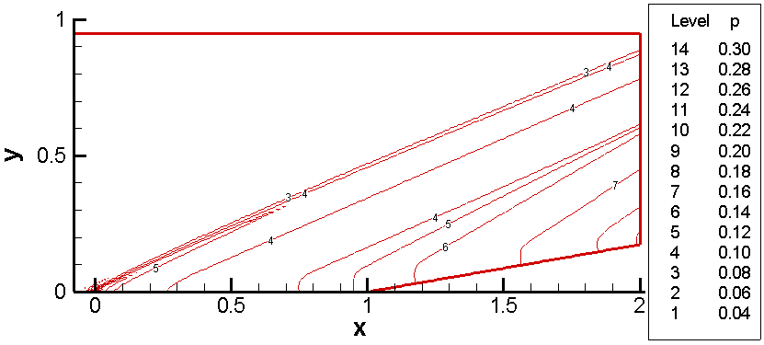
Figure 16 - Compression Corner Pressure Contours

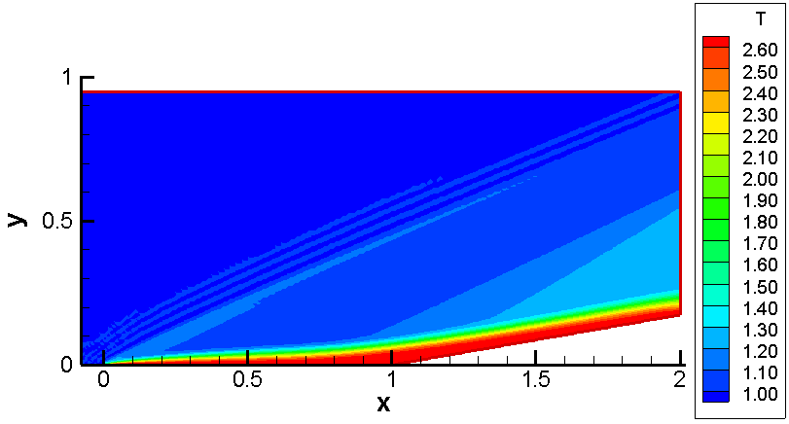
Figure 17 - Compression Corner Temperature
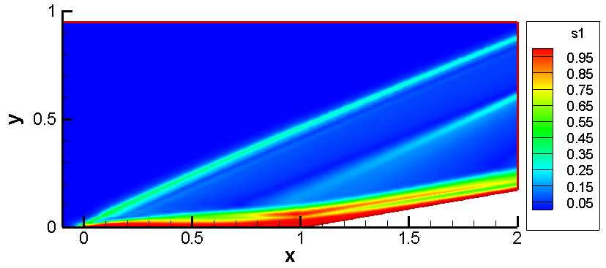
Figure 18 - Compression Corner s₁ contour

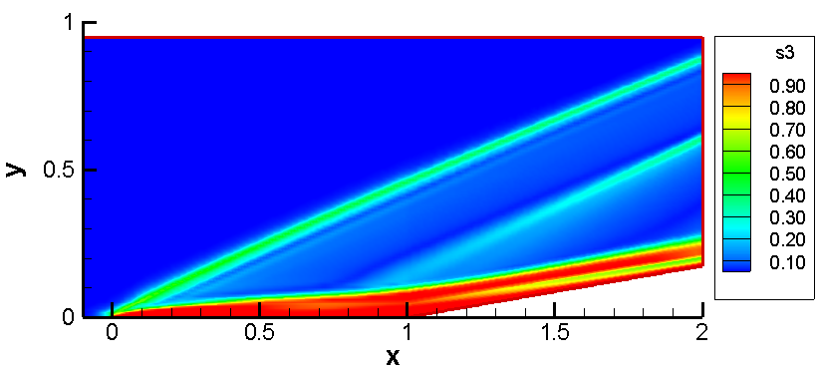
Figure 19 - Compression Corner s₃ contour

The s₁ and s₃ parameters again do an excellent job of representing the flowfield physics, identifying the shock waves and boundary layers in the flow.

One interesting thing to note in Figure 18 is the secondary region of high s₁ value above the compression corner. This is an artifact of the grid I used, which is show in Figure 20. I had attempted to refine the grid near the boundary layer for a few reasons. One was to capture more of the boundary layer profiles. Another was because, at higher Reynolds numbers, I had issues with my code generating negative numbers at the compression corner (x=1.0, y=0.0) due to the rapid changes in flow properties through the compression. So I had several options: change parameters like the CFL number which would globally slow down the convergence of the solution, refine the entire grid which would also increase the computation time unnecessarily, or just refine in the boundary layer, which would increase computation time but only provide fidelity where it mattered. The latter route was chosen. However it appears I should have either kept the higher fidelity grid through a thicker boundary layer, or I should have had a smoother transition from the boundary layer to the free stream grid cell sizes, because it seems the transition alone influenced the trip from a low s₁ number to a higher s₁ number. If I had more time, I would have re-worked the grid and re-run my solution and experimented, but such is for another time.

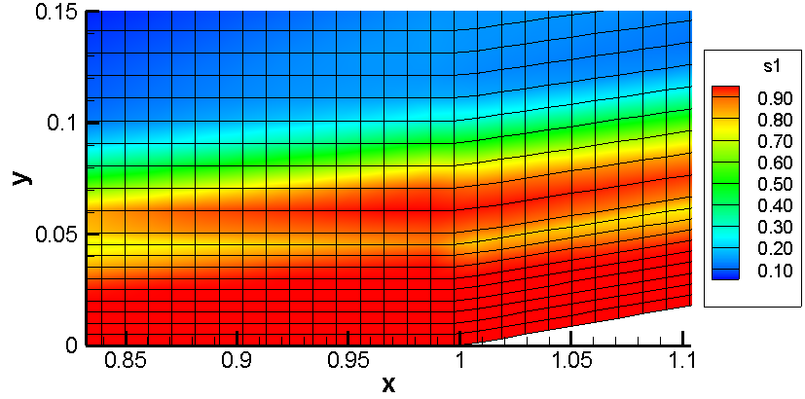
Figure 20 - Compression Corner Grid Refinement

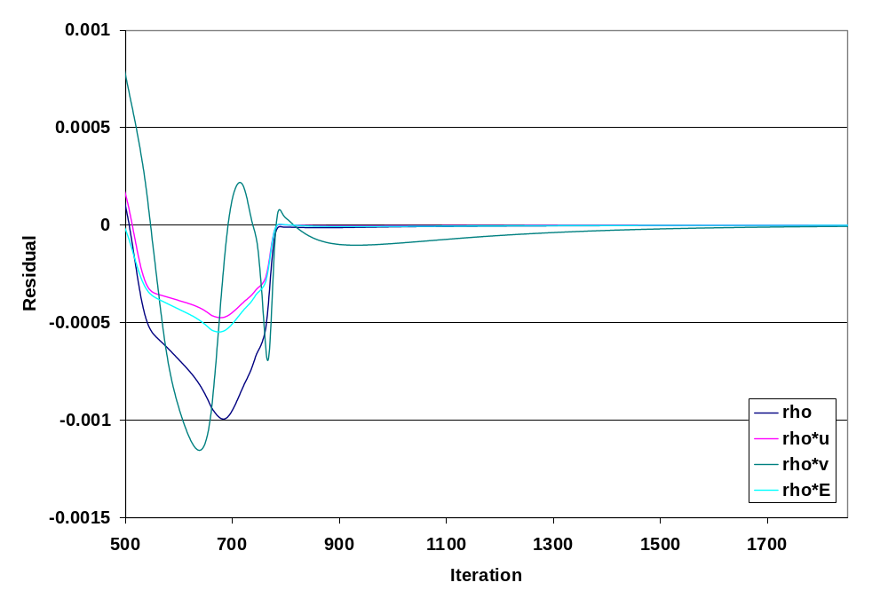
Figure 21 - Compression Corner Residuals

Figure 21 shows the residuals for the conservation variable through 1850 runs. In truth I probably should have ran it longer, the ρv residual was about an order of magnitude less than the other residuals, however the flow looked quantitatively steady over the course of a few hundred runs when visualized.

Lid Driven Cavity Flow

The lid driven cavity flow consists of a cavity with three solid adiabatic walls and flow across the top of the cavity, tangential to the open face. M=0.1, Re=1000, Pr=0.72.

Table 6 - Lid Flow Domain and Boundary Conditions
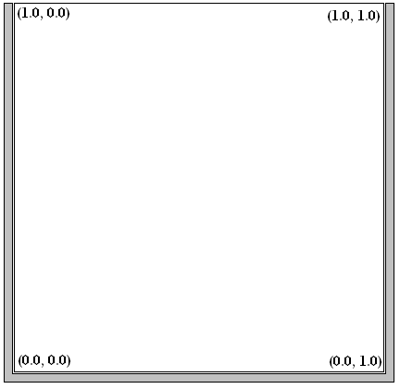

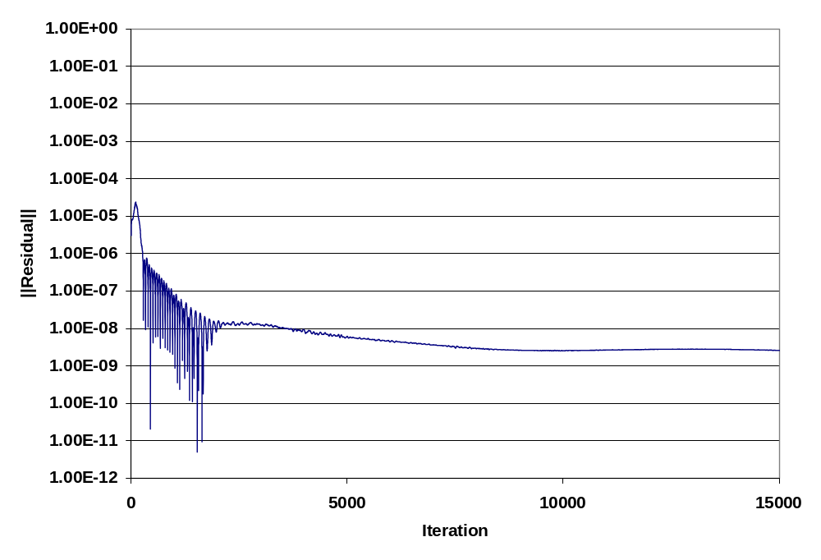
Figure 22 - Lid Flow Convergence

It took about 10,000 iterations to really stabilize on a set of results. This seems to be the case in general for subsonic flows; it takes a long time for the information to propagate through the mesh as compared to the supersonic flows of similar size and shape which converge in a few hundred iterations. This demonstrates the difference in flowfield mechanics between the subsonic incompressible and supersonic flows.
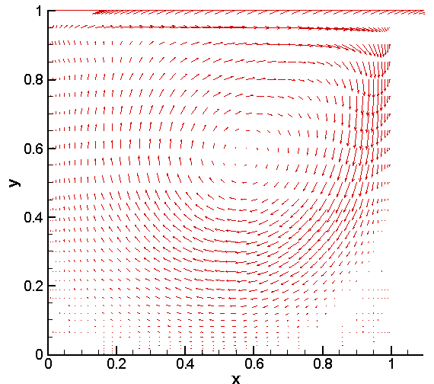
Figure 23 - Lid Flow Vector Plot

Figure 23 shows the vector plot of the system, however due to the variance in magnitudes between the primary region and the separated regions it is useful to look at Figure 24 which traces the path of a particle through the cavity. Two separated regions in the bottom corners are clearly seen.

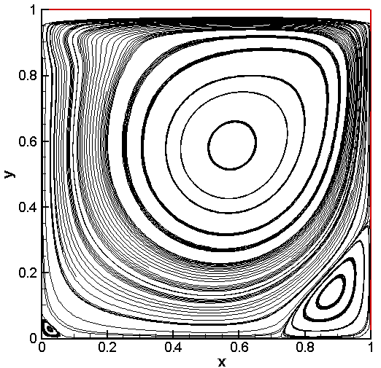
Figure 24 - Lid Flow Stream Traces

Rearward Facing Step

The rearward-facing step is an incompressible duct flow with a step to demonstrate flow separation and recirculation. The flow has a parabolic velocity entering the duct and expands past the step, separating and reattaching somewhere along the wall. Between the attachment point and the step there is recirculating flow. M=0.01, Re=100, Pr=0.72.

Table 7 - Back Step Domain and Boundary Conditions
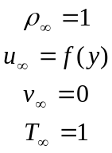 | 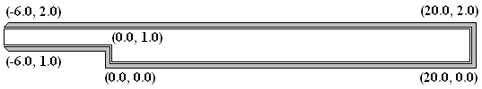

This case is currently being run on my home computer; the following results have not converged. Unfortunately I just didn’t have the time to complete every case I would have liked to, and this one was one of the sacrificial cases.

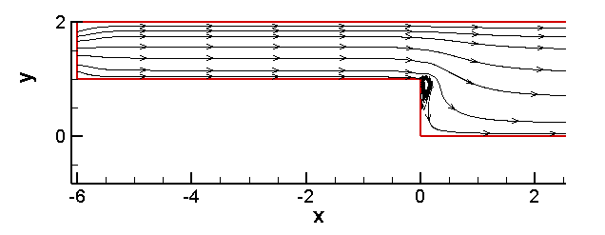
Figure 25 – Rearward Facing Step Stream Traces - HAVE NOT CONVERGED

Initially there was no region of recirculation; the flow came across the edge of the step very sharply. Over time the area of recirculation has formed and expanded outward in the positive x direction and down towards the base of the duct. These results are after about 730 iterations. It will probably take several thousand iterations, like the lid flow, for this subsonic case to converge.

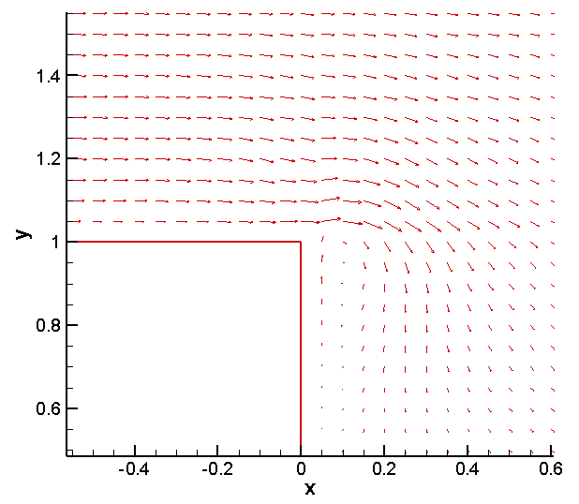
Figure 26 - Rearward Facing Step Vector - HAS NOT CONVERGED

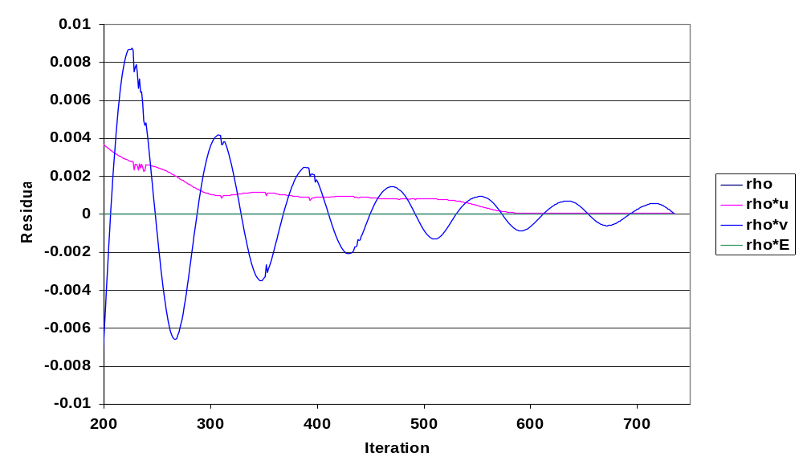
Figure 27 - Rearward Facing Step Residuals - HAS NOT CONVERGED

As you can see the ρv residual is still very large, and will need awhile to converge on the appropriate solution.

Hypersonic Inlet

The hypersonic inlet closes out the six example cases I ran with my code, and utilizes the highest Mach numbers and number of grid points. Sections 5.1, 5.2 and 5.3 showed results for a flat plate and ramp in supersonic flow, sections 5.4 and 5.5 then slowed things down, demonstrating capabilities in the incompressible flow regime. Now we dial things up to Mach 20 and demonstrate hypersonic flow phenomena. The top of the domain is a solid wall, and the bottom of the domain from x=0.0 to x=1.5 is also a solid wall, geometry representative of a 2D cross-section of a hypersonic inlet under a wing. M=20, Re=0.3E6, Pr=0.72.

Table 8 - Hypersonic Inlet Domain and Boundary Conditions
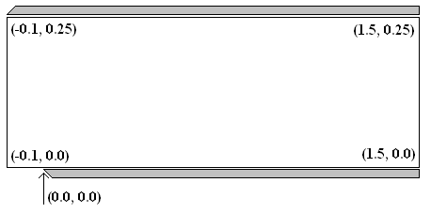

This case is currently being run on my work computer, which has four processors and an excess of RAM. The domain contains 800,000 nodes and takes roughly 13 minutes to complete a single iteration. The code is parallelized to utilize as many processors as are available on a single computer and does use all four processors for the majority of the computation space, including the GMRES solver.

Unfortunately this case as well is not converged. As of the time of this writing, 1600 iterations have been completed. Unfortunately the shock-boundary layer interactions are just starting to take place. Examining Figure 28 we can see the formation of boundary layers along both surfaces and the shock formations. Up to x=0.34 is very well resolved. As the inflow boundary conditions continue to propagate down the domain, the domain will continue to resolve. However even at this point we can begin to see some boundary layer-shock interaction even though the shock has not converged, as show in Figure 30. The impinging shock is scrubbing the boundary layer and causing a recirculation in the flow to form. The flow stream traces are plotted on top of the s₁ contours which depict both the boundary layer and shock wave impingement. It will probably take another week until these interactions are fully resolved and another two weeks to fully resolve the entire domain. I will update this report at that time.
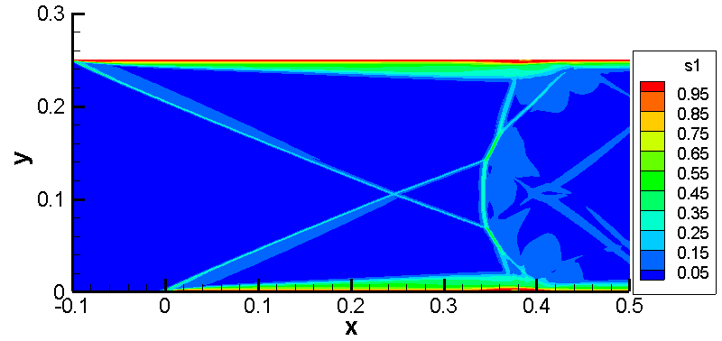
Figure 28 - Hypersonic Inlet s1 parameter - HAS NOT CONVERGED

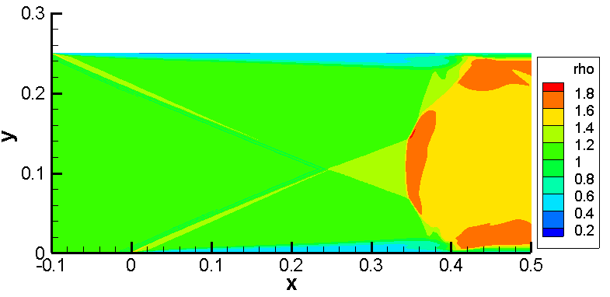
Figure 29 – Hypersonic Inlet Density - HAS NOT CONVERGED
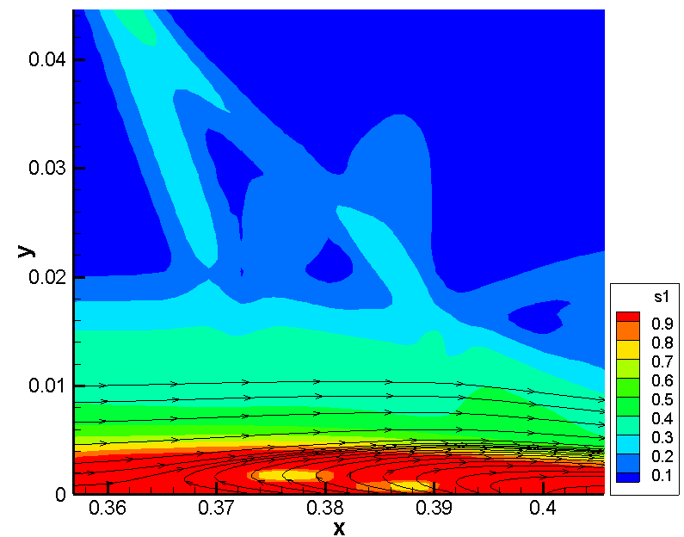
Figure 30 - Hypersonic Inlet Streamtraces and s₁ Contours - HAS NOT CONVERGED

Conclusion

I presented results generated using the same code without modification from M=0.05 to M=20. For the solutions presented, my code appears to provide a good match to existing results presented both by former students utilizing FDV codes and with theory, although I would like to make more comparisons than I presently have had time to do. I feel confident that within the domain of testing I have performed, the range of Mach numbers, pressures, temperatures and boundary conditions implemented, that my code can perform well and give meaningful results.

Further Investigation

However, 2D is not very representative of real life design, excepting special circumstances. The next thing I would like to do is expand my code into three dimensions. I believe I programmed my code in such a way that this should be a straightforward endeavor once the Jacobians and fluxes are programmed.

I’d also like to examine turbulence as it naturally arises in FDV, and heat transfer. These issues are relevant to what I do at work and it would be interesting to be able to compare the potential of FDV theory to existing codes and wind tunnel data I have on hand.

In addition, I would like to change the parallelization to make it work on clusters and distributed computers. I presently use OpenMP to parallelize loops, which works very well for a single computer with multiple processors, but does not allow multiple computers to tackle one problem in parallel. The solution is to re-work the parallelization using MPI, a standardized Message Passing Interface commonly used in scientific computing.

There are many other interesting things to investigate, like chemically reacting flow, ionized flow, etc. I’m sure I will have no trouble keeping myself busy with this project for quite some time.

Appendix A – Source Code

This is not exactly a Taylor series expansion, but similar.
Computational Fluid Dynamics, T J Chung, pg. 170-172 for 2D and Appendix A for 3D
Computational Fluid Dynamics, T J Chung, §6.5.1
See Chung, §9.3.3
Also known as a shape, interpolation or basis function
Chapter 9, Computational Fluid Dynamics, Chung.
Or a “wife or child” failure.

